CREATE A DATABASE IN CLOUDANT DB

|  |  |
| --- | --- |
| Date | 08-11-2022 |
| Team ID | PNT2022TMID15125 |
| Project Name | Project - IOT based safety gadget for childsafety monitoring and  notification |
| Maximum Marks | 4 Marks |
| Submitted By | Y HIMA SREE, V SRIJA,J SHARMILA,P HEMA LATHA |

Create A Database In Cloudant DB

Aim: To create a database in Cloudant DB to store location data.

Steps followed:

* Logged in to IBM Cloud account
* Navigated to `./resources`
* Clicked on the “Create Resource +” button
* Searched for “Cloudant”
* Chose the “Lite Version” and clicked on “Create”

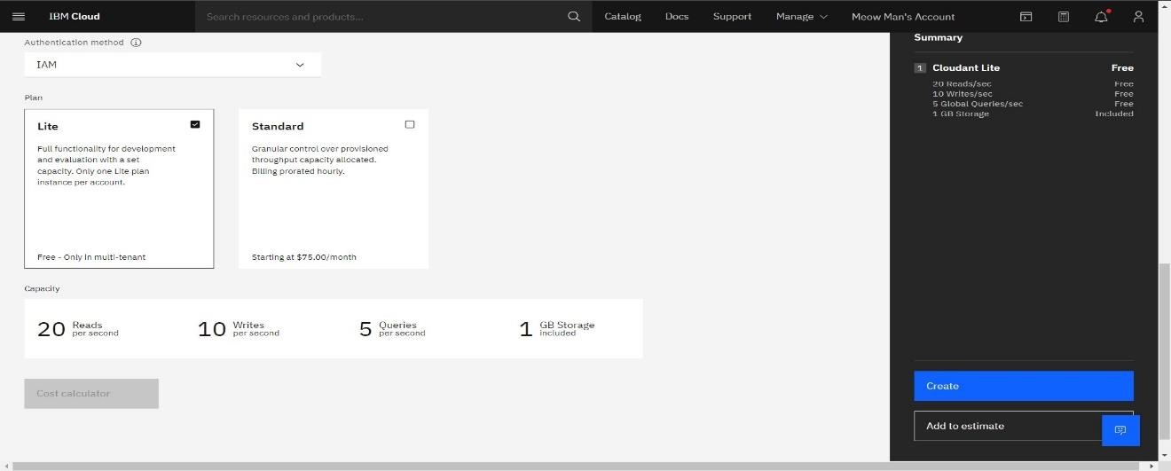

* The Cloudant database resource was created successfully

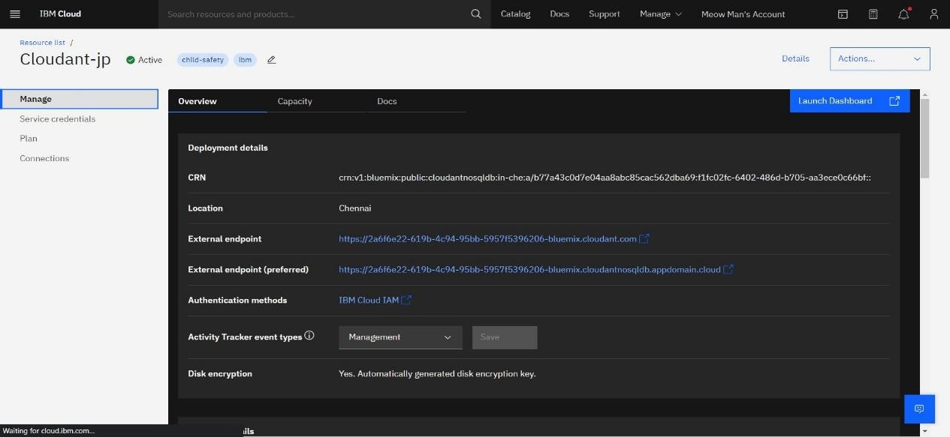

* Clicked on Launch Dashboard

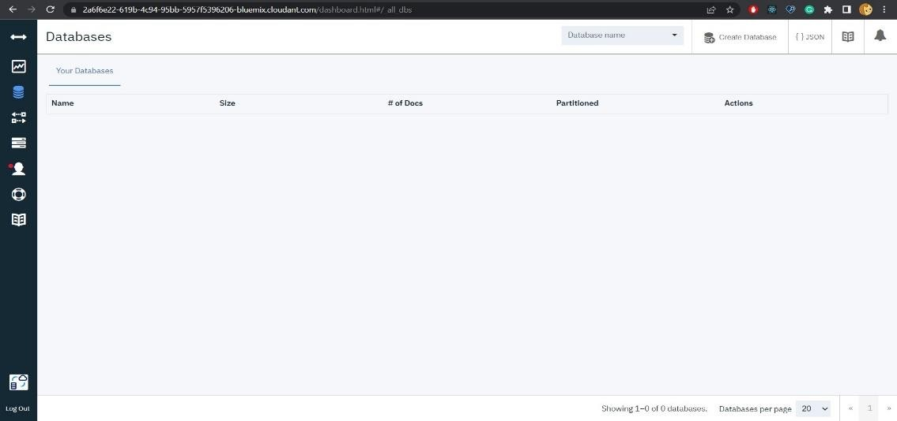

* Clicked on “Create Database”. Entered “meowman” as the database name and the “Non-partitioned” option

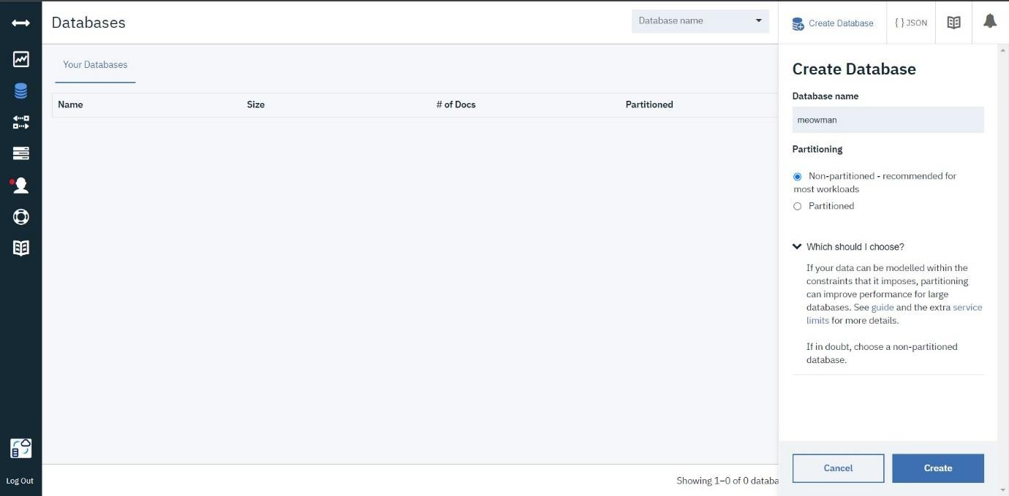

* The database “meowman” was created successfully

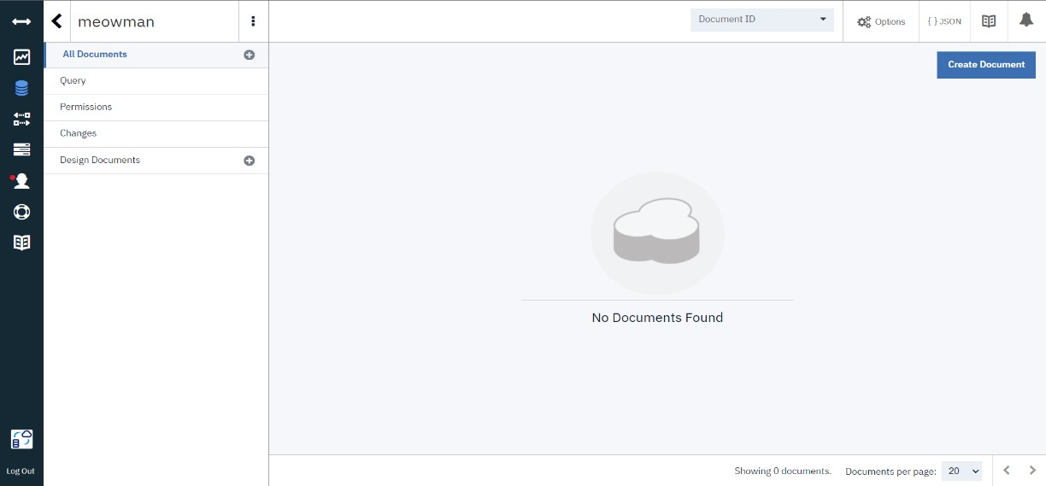

Result:

A database to store the location data was created successfully on Cloudant DB